Overview
This checklist will help you prepare for the installation of XC_iGen5_EX-P_5_RX_FD50_WinRel1.zip

General Information
- Product Name | EFI Fiery™ for iGen5 Press
- Current Version | V1.1
- Defect ID | FIT101164618
- Release Date | 03-11-2015
- Files included | XC_iGen5_EX-P_5_RX_FD50_WinRel1.zip
- File size | 61032841 bytes
- Checksum | 419063887

Issue(s) addressed with this release
- Windows PS drivers to update the Fiery driver version to 5.0.


Before installing XC_iGen5_EX-P_5_RX_FD50_WinRel1.zip
- Please review the addendum before installing the updated driver.

Windows driver installation instruction
- Please use the Fiery_Printer_Delete_Utility provided on the User Software DVD to uninstall the previously installed fiery driver.
- Reboot the client system after the driver has been uninstalled.
- Unzip the XC_iGen5_EX-P_5_RX_FD50_WinRel1.zip file on to your desktop.

- Install the driver from the unzipped folder using the Add Printer wizard. Remember to point the installer to the location of the unzipped folder.

Addendum:

Fiery PostScript Driver version 5.0 has been released to support Windows10
This document contains important information about this update release. Be sure to read this information before proceeding with the installation.

OS Versions supported:

The Fiery PostScript Driver version 5.0 can be installed on the following Windows OS versions:

• Windows 7 (32 bit and 64 bit)
• Windows Server 2008 (32 bit and 64 bit)
• Windows Server 2008 R2
• Windows 8 (32 bit and 64 bit)
• Windows Server 2012 (32 bit and 64 bit)
• Windows Server 2012 R2
• Windows 10 (32 bit and 64 bit)

Installation:

Microsoft Windows 8 and later, including Windows 10, only allows installation of digitally signed drivers. To meet this requirement, the Fiery Driver installer includes EFI’s VeriSign digital signature. By including EFI's digital signature, the user will not see the 'Windows Security' dialog box with the message, “Windows can’t verify the publisher of this driver software".

Fiery Driver 5.0 includes the Fiery Driver Updater, which notifies the user when a driver update is available and allows the user to apply updates.

To begin installation:

1. Select the filename.zip file.
2. Right-click the .zip file.
3. Select 'Extract All'.
4. Click the "Show extracted files when complete" checkbox.
5. Click 'Extract'.

NOTE: Remember the location of the extracted files.

6. In the directory where the Fiery Driver files have been extracted, double-click the ‘PRNTDRV.EXE’ file to start the installation. The following screen will be displayed while the files are being extracted.

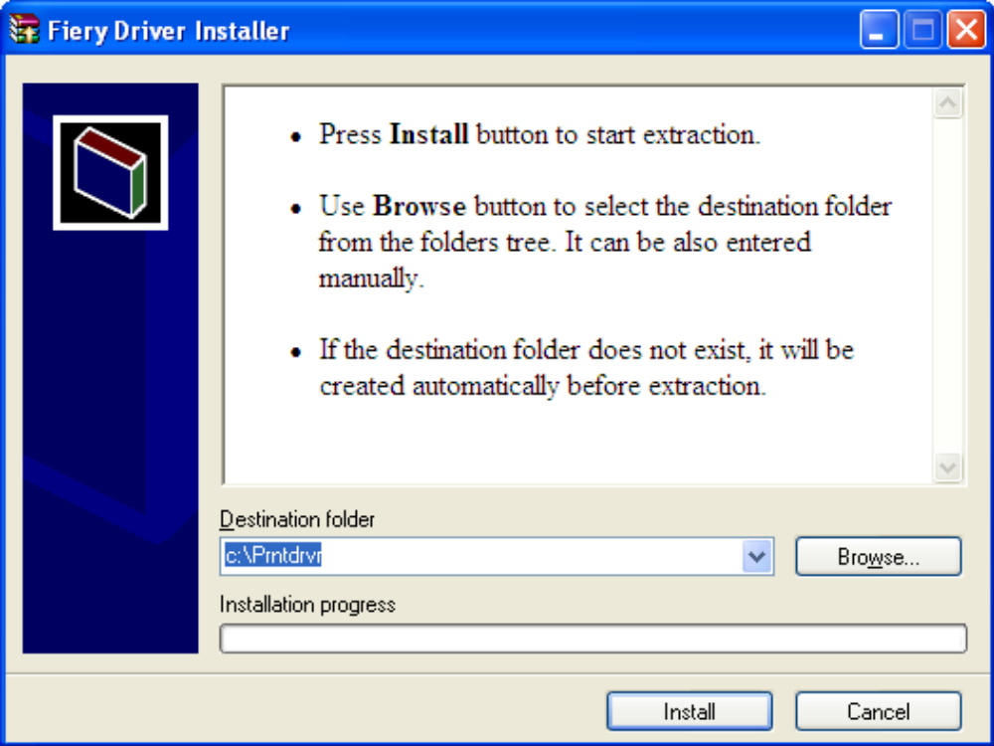

7. After extracting the Fiery Driver files, go to "Devices and Printers" in the 'Start ‘menu.
8. Click 'Add a Printer'.
9. Browse to the directory location of the extracted Fiery Driver files.

10. Select the printer model/OEMSETUP.INF file for the driver to be installed. In the example below, the resulting dialog box will have a line at the bottom that says, “This driver has an Authenticode (™) signature.” This is EFI’s VeriSign signature that is included with the Fiery Driver.

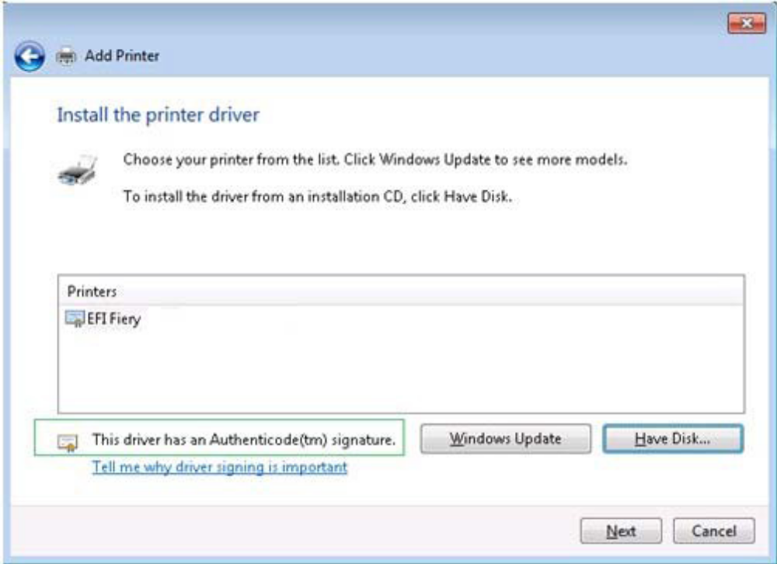

11. After selecting your printer, click 'Next'. The following dialog box will be displayed. By clicking the “Always trust software from EFI software” checkbox, this message will no longer be displayed on the current computer.

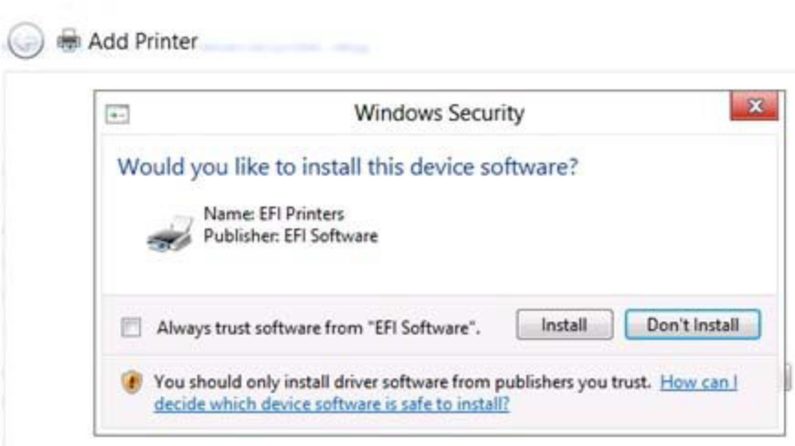

12. Follow the on-screen instructions to complete the installation.

