Xerox Integrated Controller
PS / PCL Driver / Network Scanner Utility Release Notes

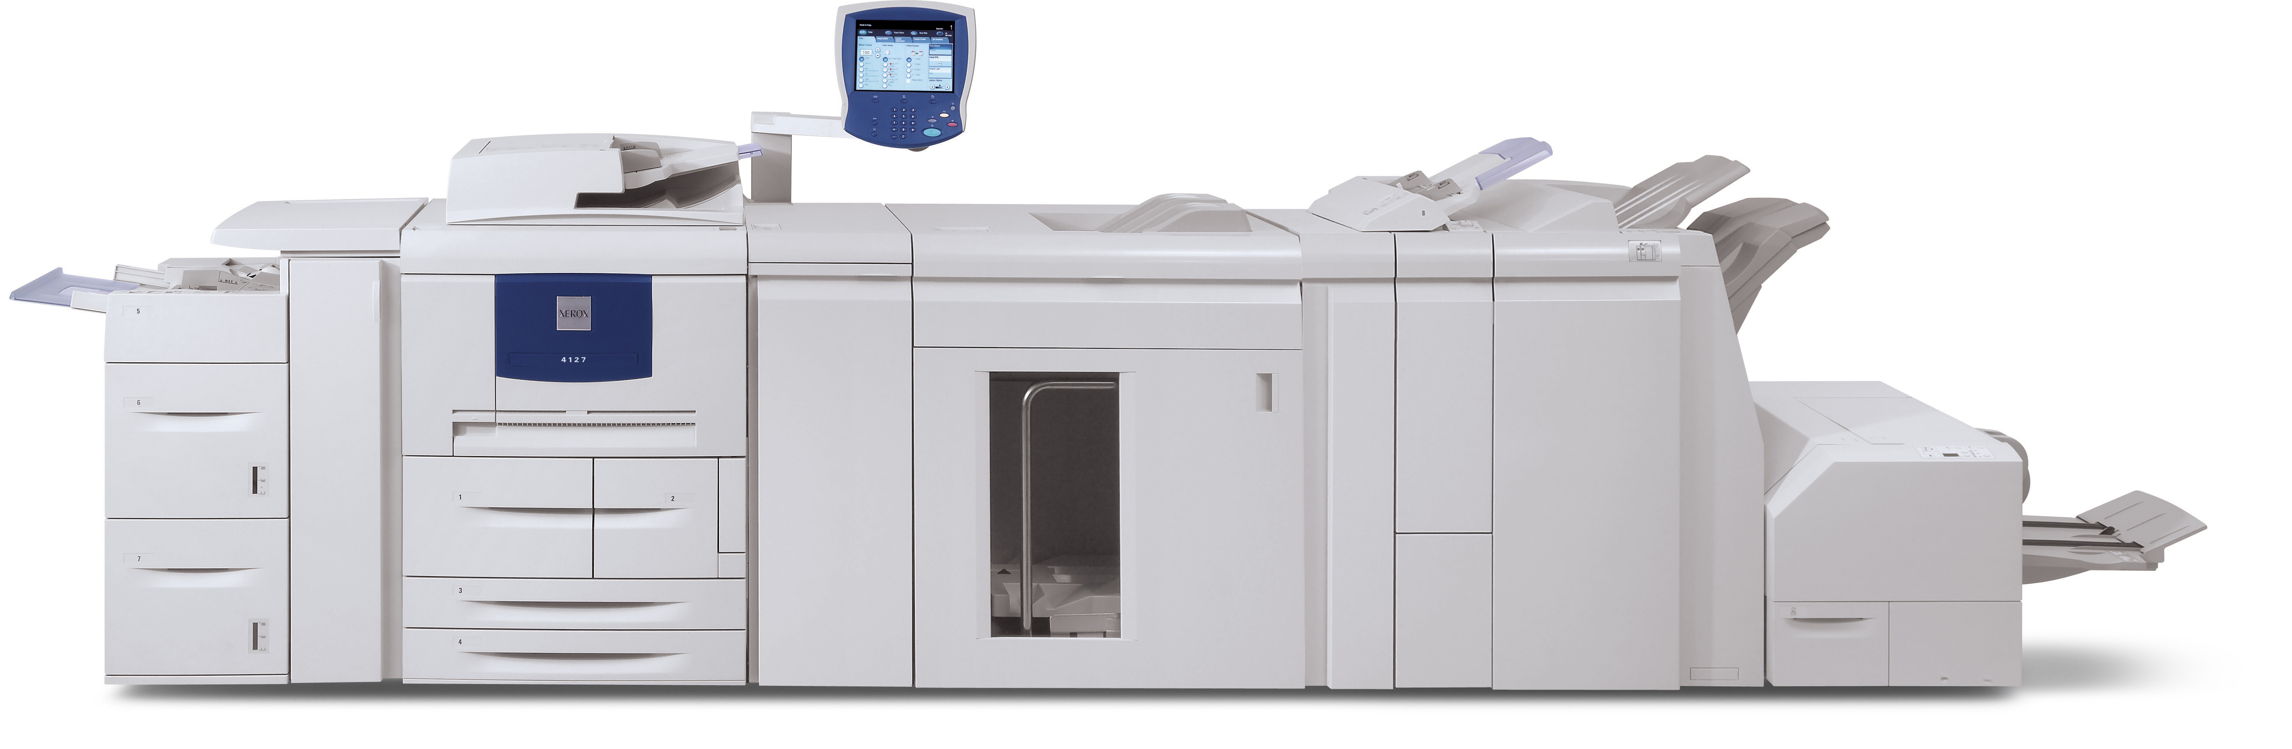

4112 / 4127

Windows 2008 Server (32 and 64 bit)
Windows 7 (32 and 64 bit)
Intel Mac 10.6

Minimum Requirement Recommendation

Recommend Internet Explorer Version 5.5 or newer to operate CentreWare Internet Services without runtime errors.
For maximum productivity, it is recommended that the job submission client/server PC that the drivers are installed on contain a 3 GHZ or higher CPU, and a minimum of 1 GB of ram installed.

For large rip jobs or images with high resolution graphics, it is recommended that EMF spooling is enabled in the Advanced Settings of the PCL or PS driver for maximum performance.

It is recommended that all applications loaded on each client/server are at the most recent available release in order to ensure compatibility.

It is required that all previous versions of the PS and PCL drivers be removed from the client/server before installing new drivers.

In order to utilize bi-directional communications from within the PS or PCL drivers, SNMP must be turned on at the IOT.

Known Application Issues

- On certain Adobe applications from Mac 10.x, multiple copy jobs are sometimes printed as a single file. This can cause unexpected results when combining hole punch and stapling options.

  - Workaround 1: Selecting “Print as Image” from the application will resolve the issue.
  - Workaround 2: For PDF files, submitting via CentreWare Internet Services resolves the issue.

- On Adobe Acrobat applications from all Windows operating systems, “Choose Paper Source by PDF Page Size” must be de-selected for multiple up printing through the PS driver.

- In CorelDraw 12, landscape jobs with stapling and duplexing options may print portrait only. This is an application issue.

  - Workaround 1: Jobs should be printed using the “Rasterize each page” option.
  - Workaround 2: Print through the PCL driver.

- Microsoft Office 2004 for Mac has application crashes and copy count limitations may occur if Word / Excel / PowerPoint versions are 11.3.5 or newer.

  - Workaround: Upgrade Office for Mac to version 2008.

- CorelDraw10 for Mac may experience application crashes when submitting via Appletalk.

  - Workaround: Submit via IP printing.

- QuarkXpress 8.0 and Macromedia FreeHand cannot create entire page watermarks from within the application.
  - Workaround: Watermarks should be setup via the driver.

- QuarkXpress 8.0 does not allow the user to specify any resolution other than 600dpi due to non-standard operational specification.

Known Operating System Limitations

- The EMF spooling option is not available on the PCL driver for Windows Vista 64.

  - Workaround: Print via the PS driver with EMF spooling enabled.

- The Specify Offset Unit cannot be set in the PCL driver on Windows Vista 64 bit.

  - Workaround: Print via the PS driver to specify offset unit.

- In certain unsupported Windows 2000 SP4 environments running Adobe InDesign CS Version 3.0 or 3.0.1, tabloid jobs cannot offset per set with collated selected.

  - Workaround 1: Print from Windows XP client.
  - Workaround 2: Print from Windows Vista Client.
  - Workaround 3: Upgrade InDesign CS to InDesign CS3.

- From Mac OSX, the Mac Cover Page feature cannot be used in combination with Special Pages.

- From Mac OSX, N-Up settings cannot be used in combination with Special Pages.

Known Settings Limitations

- Covers cannot be pulled from Tray 5 Bypass for Heavyweight stocks.

  - Workaround: Load the required cover stock in another tray.

- Advanced Punch options can not be specified in combination with Dx finisher hole punch options. This is a hardware limitation.

- Advanced Punch options can not be specified in combination with Dx finisher stapling options. This is a hardware limitation.

Known Driver Issues

PS Driver Windows 2008 Server 32 & 64 bit

- 11x17 Exception Pages on Letter Job does not Hole Punch any Pages After the Exception Page

PCL Driver Windows 2008 Server 32 & 64 bit

- Selecting 2-Staple Top and mixed size exception pages generates 016-722 IOT Fault.
- Selecting 2-Staple Bottom and mixed size exception pages generates 016-722 IOT Fault.
- Selecting 2-Hole Punch Bottom and mixed size exception pages generates 016-723 IOT Fault.
- Selecting 2-Hole Punch Top and mixed size exception pages generates 016-723 IOT Fault.
- Selecting Single Fold and mixed size exception pages generates 024-747 IOT Fault.
- Selecting Booklet Fold &Staple and mixed size exception pages generates 024-747 IOT Fault
- PDF files flip landscape image on the first page of the first job (64 bit only).
- Watermarks fail to resize correctly on letter exception pages in a tabloid job (Word, PP, and PDF)
- Watermarks do not show up on the printed output (64 bit only).

PS Driver Windows 7 32 & 64 bit

- Bi Fold Multiple Sheets Constraints do not match IOT. Specifications. 5 is the maximum supported.
- Watermarks fail to resize on Letter Exception Pages (Word, PP, and Adobe)
- PS Driver Contrast settings are Set to Max and Have no Adjustment Capability
- Bi Fold Multiple Sheets Custom Divide Default is Off. Actual output is divided into 5 sheet sets
- Print images fails to resize on Letter Exception Page (PDF and PP)

PCL Driver Windows 7 32 & 64 bit

- Unable to Turn On EMF Spooling on PCL Driver 64 Bit
- When Variable Reduce / Enlarge is deselected, % box is not grayed out (32 and 64 bit)
- There is a preview image overlap in Watermark Print Preview. This does not effect output.

PS Driver Mac OSX 10.6

- Watermarks fail to resize on Letter Exception Page (Word, PP, and PDF).
- Right top tray is selectable for booklet output delivery.
- 11x17 SEF Jobs Advanced Punch Options are available. This is not supported.
- The image fails to resize on Letter Exception Page (PDF and PP).
- The Booklet Trimming Option is available on non-folded jobs. This is not supported.
- Watermark Option is Selectable But Not Functioning for PDFs.
- 11x17 Exception Pages on Letter Job does not Hole Punch any Pages After the Exception Page
- Booklet Pressing Option available on non-folded jobs. This is not supported.
- Exception pages are allowed with booklet folding and stapling. This is not supported.
- Z-Fold Half Sheet on Letter Paper is selectable. This is not supported.
- Creating a booklet with a cover page causes the IOT to crash
- Multi-page up printing causes 116-703 IOT error from PDF only.
- Graying out of an option does not cause it to be de-selected. The application must be closed and restarted.
- Exception pages will not turn off when deselected. The application must be closed and restarted.
- Top and Bottom Three-hole punch options are selectable on 8.5x11 paper. This is not supported.
- Watermarks fail to resize on Letter Exception Page (Word)
- The image fails to resize on Letter Exception Page (PDF and PP)
- Booklet fold and staple with Cover page at beginning fails.

Known CentreWare Internet Services Issues

- Unable to specify Advanced Punch Options for jobs submitted via CentreWare.

  - Workaround: Print from the PS or PCL driver.

