Xerox Integrated Controller
PS / PCL Driver
Installation Instructions

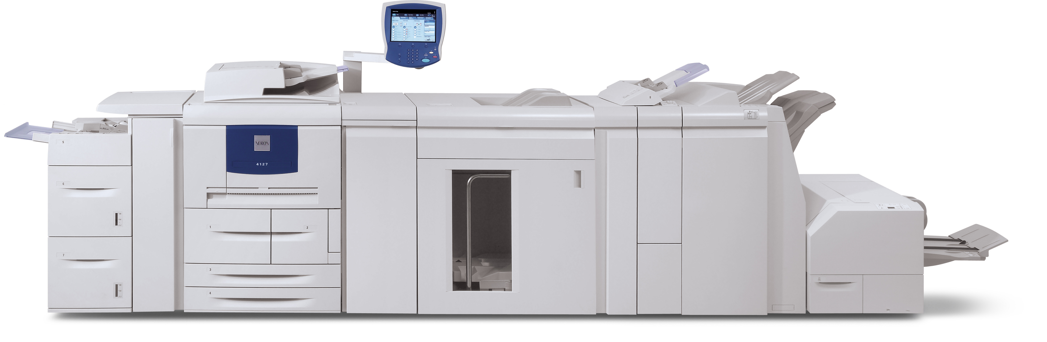

4112 / 4127

Windows 2000 / Windows 2003 Server / Windows 2008 Server / Windows XP / Windows Vista / Windows 7
Mac 10.6 / Network Scanner Utility / TWAIN

Overview

These instructions are for installing PostScript (PS) and Printer Command Language (PCL) drivers on Windows and Macintosh clients or servers to enables printing on the 4112 / 4127 family of Xerox Light Production Monochrome (LPM) printers.

Before You Begin

- Make sure that your printer is powered on and is connected to the same network as your clients and servers.

- Write down the Internet Protocol (IP) address for the printers you want to print to in order to simplify the installation process.

- If you have any previously installed PS or PCL drivers on the clients and servers you intend to use, be sure to completely remove the old drivers before continuing with this installation.

Contents

PS drivers on Windows Operating Systems (32 and 64 Bit) Page 5

PS Driver on Mac Operating Systems Page 7

PCL drivers on Windows Operating Systems (32 and 64 Bit) Page 8

XPA and TWAIN Utility on Windows Operating Systems Page 10

PS drivers on Windows Operating Systems (32 and 64 Bit)

Microsoft Windows Operating Systems

- Insert the PS/PCL driver CD into the CDROM.
- Select START / SETTINGS / PRINTERS (on Windows 2000) or START / PRINTERS AND FAXES (on Windows 2003 Server) from the start menu.
- Select ADD PRINTER.
- Select NEXT.
- Select LOCAL PRINTER.
- Select NEXT.

NOTE: If a port with the printer IP address appears in the list, then continue on to step 7.

NOTE: If there is no port for the printer IP address, then continue on to step 23.

- Select the port that corresponds to you printer IP address from the pull down menu.
- Select NEXT.
- Select HAVE DISK.
- Select BROWSE and choose the CDROM drive location.
- Browse to Xerox Print Drivers/Windows/PS/32 Bit or 64 Bit.
- Select the correct language folder.
- Select the file named xrptkml.inf.
- Select OPEN.
- Select printer type Xerox 4112 or 4127 depending on your Printer.
- If prompted, select REPLACE EXISTING DRIVER.
- Name your printer for easy identification.
- Select DO NOT SHARE THIS PRINTER (Sharing the printer is optional).
- Print a test page to verify correct driver installation.
- Select FINISH.
- Once test page has printed, select OK.

CONGRATULATIONS! The driver installation is complete. Now configure your feeding and finishing options!

- Browse to your printer.
- Right Click on the printer and select Properties.
- Select the Configuration Tab.
- Select the Get Information from Printer button.
- Click Apply.

- Select CREATE A NEW PORT.
- Select STANDARD TCP/IP PORT from the pull down menu.
- Select NEXT.
- Select NEXT.
- Enter the IP address of your printer into the PRINTER NAME OR IP ADDRESS field.
- Select Next.
- Specify device type as CUSTOM.
- Select NEXT.
- Select FINISH.
- Select HAVE DISK.
- Select BROWSE and choose the CDROM drive location.
- Browse to Xerox Print Drivers/Windows/PS/32 Bit or 64 Bit.
- Select the correct language folder.
- Select the file named xrptkml.inf.
- Select OPEN.
- Select printer type Xerox 4112 or 4127.
- If prompted, select REPLACE EXISTING DRIVER.
- Name your printer for easy identification.
- Select DO NOT SHARE THIS PRINTER (Sharing the printer is optional).
- Print a test page to verify correct driver installation.
- Select FINISH.
- Once test page has printed, select OK.

CONGRATULATIONS! The driver installation is complete. Now configure your feeding and finishing options!

- Browse to your printer.
- Right Click on the printer and select Properties.
- Select the Configuration Tab.
- Select the Get Information from Printer button.
- Click Apply.

PS Drivers on Macintosh Operating Systems

10.6

- Insert the driver CD into the CDROM drive.
- Browse to /Xerox Print Drivers/Mac 10.6.
- Open the 10.2.2-10.2.8 PPD folder.
- Double click the mac105ps-091117-tkmn.dmg file.

NOTE: You may need to install Stuffit Expander to expand the archive.

- Double click the Xerox Installer icon.
- Select Continue.
- Select Install.
- If prompted for an administrator password, enter it in the password field.
- When the file copy process has completed, select Close. The drivers have been installed on the Mac.
- Select System Preferences.
- Select Print & Fax.
- Add new printer by choosing the + icon.
- Select IP for network printing.
- Select Line Printer Daemon (LPD) as the protocol.
- Enter the IP address of the printer.
- Under Print Using, choose Select a Driver to use from the pull down menu.
- Choose the 4112 or 4127 printer.
- Select Add.
- Select the installable options available on your printer.

PCL drivers on Windows Operating Systems (32 and 64 Bit)

Microsoft Windows Operating Systems

- Insert the PS/PCL driver CD into the CDROM.
- Select START / SETTINGS / PRINTERS (on Windows 2000) or START / PRINTERS AND FAXES (on Windows 2003 Server) from the start menu.
- Select ADD PRINTER.
- Select NEXT.
- Select LOCAL PRINTER.
- Select NEXT.

NOTE: If a port with the printer IP address appears in the list, then continue on to step 7.

NOTE: If there is no port for the printer IP address, then continue on to step 23.

- Select the port that corresponds to you printer IP address from the pull down menu.
- Select NEXT.
- Select HAVE DISK.
- Select BROWSE and choose the CDROM drive location.
- Browse to Xerox Print Drivers/Windows/PCL/32 Bit or 64 Bit.
- Select the correct language folder.
- Select the file named xr6fmie.inf.
- Select OPEN.
- Select printer type 4112 or 4127 depending on your Printer.
- If prompted, select REPLACE EXISTING DRIVER.
- Name your printer for easy identification.
- Select DO NOT SHARE THIS PRINTER (Sharing the printer is optional).
- Print a test page to verify correct driver installation.
- Select FINISH.
- Once test page has printed, select OK.

CONGRATULATIONS! The driver installation is complete. Now configure your feeding and finishing options!

- Browse to your printer.
- Right Click on the printer and select Properties.
- Select the Configuration Tab.
- Select the Get Information from Printer button.
- Click Apply.

- Select CREATE A NEW PORT.
- Select STANDARD TCP/IP PORT from the pull down menu.
- Select NEXT.
- Select NEXT.
- Enter the IP address of your printer into the PRINTER NAME OR IP ADDRESS field.
- Select Next.
- Specify device type as CUSTOM.
- Select NEXT.
- Select FINISH.
- Select HAVE DISK.
- Select BROWSE and choose the CDROM drive location.
- Browse to Xerox Print Drivers/Windows/PCL/32 or 64 Bit.
- Select the file named XR6FMIE.inf.
- Select OPEN.
- Select printer type 4112 or 4127 depending on your printer configuration.
- If prompted, select REPLACE EXISTING DRIVER.
- Name your printer for easy identification.
- Select DO NOT SHARE THIS PRINTER (Sharing the printer is optional).
- Print a test page to verify correct driver installation.
- Select FINISH.
- Once test page has printed, select OK.

CONGRATULATIONS! The driver installation is complete. Now configure your feeding and finishing options!

- Browse to your printer.
- Right Click on the printer and select Properties.
- Select the Configuration Tab.
- Select the Get Information from Printer button.
- Click Apply.

XPS and TWAIN Utilities

XPS

- Insert the PS/PCL driver CD into the CDROM.
- Browse to Xerox Print Drivers/XPS/English.
- Open the Readme.txt file and follow the install instructions provided.

TWAIN

- Insert the PS/PCL driver CD into the CDROM.
- Browse to the TWAIN folder.
- Double click on the Setup.exe installer icon.
- Select Allow on resultant popup window (Windows Vista 2008 Server, and 7).
- Select Language.
- Click OK.
- Click NEXT.
- Click Install.
- Select Finish.

